Beau Jackson

Assignment One

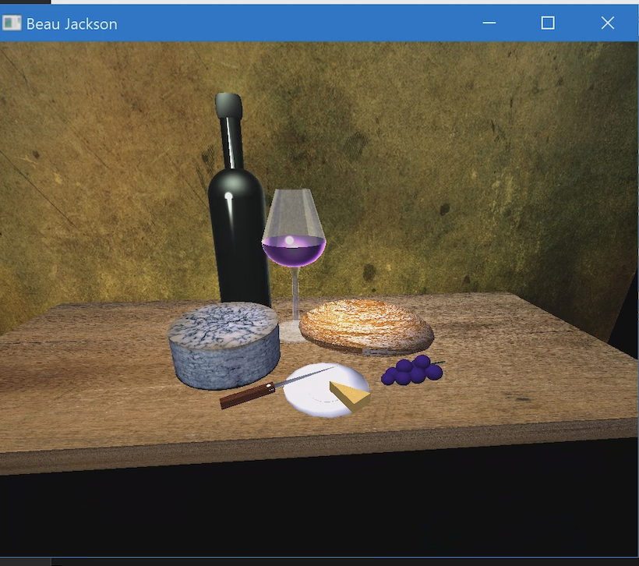

I hadn’t thankfully experienced any challenges running OpenGL. I was able to change the code to include my name and run without any issues. This was something I was happy about and was able to see the scene with no issue.